Name: ICT Assessment: 6E-6M Teaching Group:
 | DIGITAL LITERACY  Understanding of how to use technology safely and responsibly. | COMPUTER SCIENCE (Choose unit)  Ability to design write and debug programs; knowledge of sequencing and logical reasoning. |  | INFORMATION TECHNOLOGY  Ability to demonstrate basic IT skills and use of software to explore, present ideas & solve problems. | CHARACTER  Personal, social and interactive beahvour within lessons.  Holistic development.
Secure/  Mastered | I can explain why it is important to remain safe when using the internet whilst understanding the dangers and ways to protect myself.  I can confidently identify content that is appropriate to share online and how to use the internet responsibly. | I can add voice sounds to enhance an animated story.  I can add interactive user features to a scene or story. | I can program a character to be controlled around a custom track to reach a goal.  I can program a character to follow an automatic path. | I can plan and calculate a spending budget.  I can design a spreadsheet for a specific purpose. | I can always be first to volunteer to help support staff within lessons.  I can consistently contribute my own ideas to the whole class without being asked.
SECURE
Developing | I can explain why it is important to be safe when using technology, recognising the dangers and can list at least 2 ways to remain safe.  I can demonstrate a good understanding of sharing age-appropriate content, information and online behaviour when using the internet. | I can control when objects need to be visible.  I can sequence events to create a story narrative. | I can use tools and add features to create an original landscape in Kodu.  I can analyse and deconstruct code to work out its purpose. | I can add, edit and  calculate  data.  I can use a spreadsheet to solve  problems. | I can often volunteer to hand out equipment and help staff.  I can use think, pair, share skills to offer ideas to peers.
Emerging | I can describe why it is important to be safe when using technology and recognise some dangers.  I can show a basic understanding of what information is appropriate to share online. | I can create appropriate animations.  I can structure and control the timing of events. | I can investigate and evaluate the features of programming software.  I can program Kodu using When and Do instructions. | I can enter data and formulas into a spreadsheet.  I can order and present  data based on calculations | I can sometimes offer to help with handing out of worksheets/folders.  I can sometimes volunteer to show examples of work produced.
REFLECTION:
Winter |  | Spring |  | Summer
Digital Literacy | /6 | Digital Literacy | /6 | Digital Literacy | /6
Computer Science | /6 | Computer Science | /6 | Computer Science | /6
Information Technology | /6 | Information Technology | /6 | Information Technology | /6
Character | /6 | Character | /6 | Character | /6
Total | / 24 | Total | / 24 | Total | / 24
My Strength: _______________  ____________________________________________________________________________________________________________  My target: _________________  ____________________________________________________________________________________________________________  I am proud of myself because:  __________________________  ____________________________________________________________________________________________________________ |  | I have improved by _____ points  My Strength: _______________  ____________________________________________________________________________________________________________  My target: _________________  ____________________________________________________________________________________________________________  I am proud of myself because:  __________________________  ____________________________________________________________________________________________________________ |  | I have improved by _____ points  My Strength: _______________  ____________________________________________________________________________________________________________________  My target: _________________  ____________________________________________________________________________________________________________________  I am proud of myself because:  __________________________  ___________________________________________________________________________________________________________________

Superhero skills used in winter term  Creative thinker  Reflective learner  Self-manager  Effective participator  Independent enquirer  Team worker | Superhero skills used in Spring term  Creative thinker  Reflective learner  Self-manager  Effective participator  Independent enquirer  Team worker | Superhero skills used in summer term  Creative thinker  Reflective learner  Self-manager  Effective participator  Independent enquirer  Team worker
What fruits of faith have you used:  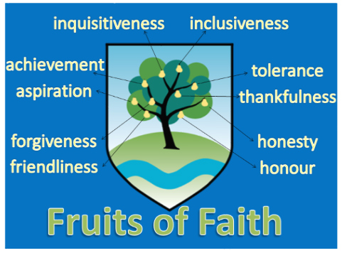 | What fruits of faith have you used: | What fruits of faith have you used:
E = 0-6 D = 7-13 S = 14-19 M = 20-24

